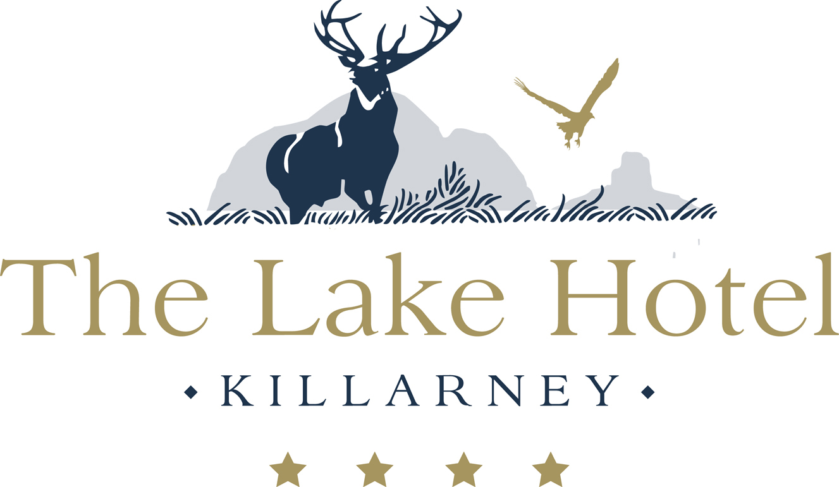

Appetisers
Warm Smoked Skeaghanore Duck (g.f)
Sweet Potato Fondant, Squash Puree
Lightly Spiced Jus

Ketaffi Prawns
Mango Salsa, Basil Mayonnaise and Chili Jam

Trio of Smoked Fish
Spillanes Smoked Salmon Blini, Smoked Haddock Fish Cake
and Smoked Trout Tartare with Citrus Hollandaise

Warm Saddle of Rabbit and Annascaul Black Pudding
White Onion Mousseline, Veal Jus

Cantaloupe Melon Cocktail (g.f) (h.o) (V)
Watermelon Lime and Mint Granita

(h.o) – Healthy Option, (g.f) – Gluten Free, (V) - Vegetarian

Main Course

Supreme of Irish Corn Fed Chicken
Charred Baby Leeks & Chive Cream

Grilled 8oz Irish Hereford Sirloin Steak (g.f)
With Crispy Onions, Stuffed Tomato & Mushroom Duxelle
Pepper Sauce or Garlic Butter

Ballontine of Atlantic Salmon (g.f)
Broad Beans, Black Olive Crisp and Tomato Consomme

Roasted Breast of Barbary Duck
With Quince Puree, Butternut Squash Risotto and Merlot Jus

Oven Baked Fillet of Skate
Herb Crust, Garlic Creamed Potato
Lemon Butter Sauce

Additional Main Courses
Supplements Apply

Pan Seared Fillet of Brill
With Sautéed Wild Mushrooms,
Green Asparagus Spears and Red Wine Reduction
Supplement €5.00

Roasted Rack of Kerry Mountain Lamb
With Lamb Skewer, Pearl Barley and Parsnip Puree
Supplement €5.00

Grilled 8oz Irish Fillet Steak
With Fondant Potato, a Wild Mushroom
Shallot & Pancetta Sauce

Supplement €7.00
All main courses are served with a selection of fresh vegetables & potatoes
Or salad & hand cut fries
(h.o) – Healthy Option, (g.f) – Gluten Free

Vegetarian & Vegan Menu

Starters

Bluebells Falls Goats Cheese Salad
Heirloom Tomato, Rocket Leaves &
Hazelnut Dressing.

Traditional Caesar Salad
Parmesan, croutons, Olives, Cherry Tomatoes,
Baby Gem Lettuce & Caesar Dressing

Antipasto Vegan Board,
Chargrilled Vegetables, Kalamata Olives,
Tomatoes, Hummus
& Toasted Cherry Tomato Focaccia

Cream of Homemade Soup
(G.f on request)

Main Course

Brochette of Halloumi Cheese
Mediterranean Vegetables, Spiced Tomato Cous Cous
Coriander oil & Greek Dressing

Open Beetroot & Mushroom Ravioli
Filled with Fresh Gnocchi, Green Asparagus
& Parmesan Cream

Home Nut & Herb Roast,
Tomato Ragout, Rocket Leaves,
& Asparagus

Lemon & Basil Tofu (vegan)
Chargrilled Vegetables
& a five Bean Casserole

Dessert

All our Desserts on our Table D’ote Menu are Vegetarian
& the following Dessert is also Vegan

Warm Balsamic marinated Local Strawberries,
Strawberry Sorbet & Mint Syrup

Smooth Chocolate Mousse
With a Mixed Berry Compote Raw Coconut and Cashew Ice Cream

Dessert

Mini Doughnuts ‘Lake Hotel Style’
With Espresso & Ice Cream Affogato

Baileys Crème Brulee (g.f on request)
Chocolate & Hazelnut Biscotti, Mocha Ice Cream

Autumn Raspberry Plate
Raspberry & White Chocolate Parfait, Baked Shortcake, Raspberry Sorbet
& Buttermilk Mousse

Strawberry & Vanilla Cheesecake De-Construction
With Macerated Strawberries & Champagne Sorbet

Selection of Mac’s Ice- Creams
Raspberry Fruit Mousse

Trio of Lake Hotel Chocolate Board
Warm Fondant, Delice & Opera Cake with Malteaser Ice Cream

Additional Desserts
Supplements Apply

Irish Cheese Board
Grape Chutney, Local Honey, Pickled Walnuts & Toast Crackers
€2.50

Petit fours
€3.00 per person
****
Table D’ote Menu
Two Courses €30.00
Three Courses €38.00
With freshly brewed Tea or Coffee

****

Our seafood is sourced from Spillane's Seafood of Fossa Killarney
All our Meats are 100% Irish & some sourced locally from Cronin's Butchers
Poultry from Pat Clifford Killarney
Ice Creams are sourced from Mac’s Main Street Killarney
All our sauces & soups are suitable for a gluten free diet
****

